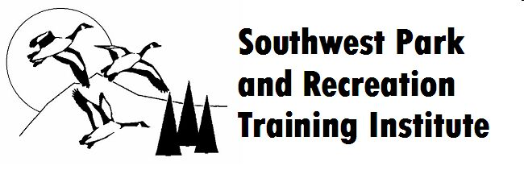

Professional Grant Application

The professional grant awards recipient(s) a waiver of conference registration fees, lodging and meals to attend the 2024 Southwest Park and Recreation Training Institute held Sunday February 5th through Wednesday February 8th, 2024, at Sequoyah State Park in Oklahoma on Ft. Gibson Lake.

Application Period: Application must be digitally submitted by December 8, 2023

Grant Award Decision: Recipients will be notified of award by December 15, 2023.

Eligibility:
Candidates must be currently active in the parks and recreation profession and must clearly express the need for financial assistance to attend the Institute. Candidates must demonstrate a significant level of personal achievement and contribution to the park and recreation profession. Candidates with any previous attendance at the annual Institute or past level of involvement at the Institute will be given priority consideration.

Application Checklist:
o Cover Letter o Resume o Letter of Recommendation

Cover Letter:
The cover letter should answer the following questions;
- How you are currently and actively involved in the parks and recreation field.
- Significant contributions and achievements you have made to the profession.
- Explanation of the financial need for the grant
- Your personal and organizational benefit to attending the 2023 Institute
Resume:
Highlight relevant work experience, education, recognition’s, publications, memberships in professional organizations, conferences attended, training, research, etc.
Letter of Recommendation:
Include one (1) letter of recommendation from a parks and recreation professional addressing your achievements that make you a quality candidate for this grant. This letter should focus on your commitment to the parks and recreation field, your accomplishments in the profession, and how attendance at the Institute would benefit your organization.

Application Submittal: **digital submission only**
Send your signed application along with required supporting documents by the application deadline to:
SWPRTI Scholarship Committee Chair Greg Snider gregsnider62@gmail.com 405-606-5824

For more information on the Institute and its objectives in fostering, supporting, and promoting professionalism in the parks and recreation industry, please visit our website at SWPRTI.org

I certify the information given herein is true and correct and may be used by the Southwest Park and Recreation Training Institute Scholarship Committee.

Signature of Applicant | Date

